**Green Village Manager**

**HCI Project**

Supervised by:

*Dr-Wafaa*

**System introduction**

**1. Overview**

Greater Aghor Village Application

Includes some services.

- Latest village news.

- Create an account and add data.

- The doctors.

- Communications.

-Libraries.

-Technical.

-Teachers and pharmacies.

The application saves time and effort to search for places and times of institutions located in the village and a way to communicate with all members of the village to share their daily conditions as a social communication application.

**Target User**

Residents of the Greater Aghour Village who live in it or residents outside the village who come to visit it. It provides ease of use for the elderly or people with weak vision.

**Goal**

Save time searching for places and providing organized services. The application is to find schools, hospitals, stores, etc. easily.

Helping the residents of Aghour al-Kubra to communicate and spread news like other social networking applications, but intended for the people of the village, with the addition of the feature of liking and commenting on the news.

There is a feature of adding news to favorites for easy finding.

The main goal of the application is to communicate and solve the village’s problems in a way.

Smart, timesaving and up to date.

**Tasks**

The user can browse through the sections and services on the site, such as finding places, their times, and their location within the village.

A user can have more than one account and provides full protection for his data.

The admin has the right to approve the news before publishing it on the application.

The user can navigate between pages with complete ease.

The user can comment and like other people’s posts.

The user can add data in categories inside the application.

The user has ability to change language and lightening of the application.

The application has feature like change accessibility according to user condition.

The application has features like search bar using words to find it inside categories or posts.

**2.Usability Testing**

**Key participants**: Aghour El-Kobra residents.

|  |  |  |  |
| --- | --- | --- | --- |
| Criteria | Excellent | Acceptable | Unacceptable |
| Task (1) log in | | | |
| Number of clicks | 6 | 7 | 11 |
| Number of wrong clicks | 0 | 1 | 5 |
| Task (2) log out | | | |
| Number of clicks | 3 | 4 | 7 |
| Number of wrong clicks | 0 | 1 | 4 |
| Task (3) create account | | | |
| Number of clicks | 7 | 8 | 10 |
| Number of wrong clicks | 0 | 1 | 3 |
| Task (4) view favorites | | | |
| Number of clicks | 1 | 2 | 3 |
| Number of wrong clicks | 0 | 1 | 2 |
| Task (5) app appearance mode | | | |
| Number of clicks | 3 | 4 | 6 |
| Number of wrong clicks | 0 | 1 | 3 |
| Task (6) Add post | | | |
| Number of clicks | 4 | 5 | 8 |
| Number of wrong clicks | 0 | 1 | 4 |
| Task (7) view post | | | |
| Number of clicks | 1 | 2 | 3 |
| Number of wrong clicks | 0 | 1 | 2 |
| Task (8) like post | | | |
| Number of clicks | 2 | 3 | 4 |
| Number of wrong clicks | 0 | 1 | 2 |
| Task (9) comment in post | | | |
| Number of clicks | 4 | 5 | 7 |
| Number of wrong clicks | 0 | 1 | 3 |
| Task (10) share, copy post | | | |
| Number of clicks | 2 | 3 | 4 |
| Number of wrong clicks | 0 | 1 | 2 |
| Task (11) search category | | | |
| Number of clicks | 1 | 2 | 4 |
| Number of wrong clicks | 0 | 1 | 3 |
| Task (12) view notification | | | |
| Number of clicks | 1 | 2 | 3 |
| Number of wrong clicks | 0 | 1 | 2 |
| Task (13) choose category | | | |
| Number of clicks | 1 | 2 | 3 |
| Number of wrong clicks | 0 | 1 | 2 |
| Task (14) add element in category | | | |
| Number of clicks | 8 | 9 | 12 |
| Number of wrong clicks | 0 | 1 | 4 |

**Tasks Evaluation:**

**Results Of Usability Testing (Aghour El-Kobra’s category)**

|  |  |  |  |  |  |  |  |  |  |  |  |  |  |  |  |  |
| --- | --- | --- | --- | --- | --- | --- | --- | --- | --- | --- | --- | --- | --- | --- | --- | --- |
| task | U1 | U2 | U3 | U4 | U5 | U6 | U7 | U8 | U9 | U10 | U11 | U12 | U13 | total | avg | performance |
| 1 | 7 | 7 | 6 | 7 | 7 | 8 | 9 | 7 | 7 | 7 | 7 | 7 | 7 | 93 | 7 | Acceptable |
| 2 | 3 | 3 | 3 | 3 | 3 | 3 | 3 | 3 | 3 | 3 | 3 | 3 | 3 | 39 | 3 | excellent |
| 3 | 7 | 8 | 9 | 7 | 7 | 9 | 8 | 8 | 8 | 8 | 7 | 8 | 8 | 102 | 8 | Acceptable |
| 4 | 1 | 1 | 1 | 1 | 1 | 1 | 1 | 1 | 1 | 1 | 1 | 1 | 1 | 13 | 1 | excellent |
| 5 | 3 | 3 | 3 | 3 | 3 | 3 | 3 | 3 | 4 | 3 | 3 | 3 | 3 | 40 | 3 | excellent |
| 6 | 5 | 4 | 4 | 5 | 5 | 4 | 4 | 5 | 5 | 5 | 4 | 5 | 5 | 60 | 5 | excellent |
| 7 | 1 | 1 | 1 | 1 | 1 | 1 | 1 | 1 | 1 | 1 | 1 | 1 | 1 | 13 | 1 | excellent |
| 8 | 2 | 2 | 3 | 2 | 2 | 2 | 2 | 2 | 2 | 2 | 2 | 2 | 2 | 27 | 2 | excellent |
| 9 | 4 | 4 | 3 | 4 | 4 | 4 | 4 | 4 | 4 | 4 | 4 | 4 | 4 | 51 | 4 | excellent |
| 10 | 2 | 2 | 2 | 3 | 2 | 2 | 2 | 2 | 2 | 2 | 2 | 2 | 2 | 27 | 2 | excellent |
| 11 | 1 | 1 | 1 | 1 | 1 | 1 | 1 | 1 | 1 | 1 | 1 | 1 | 1 | 13 | 1 | excellent |
| 12 | 1 | 2 | 2 | 2 | 2 | 2 | 1 | 2 | 1 | 1 | 2 | 3 | 1 | 22 | 2 | acceptable |
| 13 | 1 | 1 | 2 | 2 | 2 | 2 | 1 | 2 | 1 | 2 | 1 | 2 | 1 | 20 | 2 | acceptable |
| 14 | 8 | 9 | 10 | 11 | 10 | 9 | 11 | 10 | 9 | 8 | 10 | 11 | 10 | 126 | 10 | acceptable |

**Task Completion Rate (Aghour El-kobra ’ s Category)**

|  |  |  |  |  |  |  |  |  |  |  |  |  |  |  |
| --- | --- | --- | --- | --- | --- | --- | --- | --- | --- | --- | --- | --- | --- | --- |
| participant | 1 | 2 | 3 | 4 | 5 | 6 | 7 | 8 | 9 | 10 | 11 | 12 | 13 | 14 |
| 1 | Checkbox Ticked outline | Checkbox Ticked outline | Checkbox Ticked outline | Checkbox Ticked outline | Checkbox Ticked outline | Checkbox Ticked outline | Checkbox Ticked outline | Checkbox Ticked outline | Checkbox Ticked outline | Checkbox Ticked outline | Checkbox Ticked outline | Checkbox Ticked outline | Checkbox Ticked outline | Checkbox Ticked outline |
| 2 | Checkbox Ticked outline | Checkbox Ticked outline | Checkbox Ticked outline | Checkbox Ticked outline | Checkbox Ticked outline | Checkbox Ticked outline | Checkbox Ticked outline | Checkbox Ticked outline | Checkbox Ticked outline | Checkbox Ticked outline | Checkbox Ticked outline | Checkbox Ticked outline | Checkbox Ticked outline | Checkbox Ticked outline |
| 3 | Checkbox Ticked outline | Checkbox Ticked outline | Checkbox Ticked outline | Checkbox Ticked outline | Checkbox Ticked outline | Checkbox Ticked outline | Checkbox Ticked outline | Checkbox Ticked outline | Checkbox Ticked outline | Checkbox Ticked outline | Checkbox Ticked outline | Checkbox Ticked outline | Checkbox Ticked outline | Checkbox Ticked outline |
| 4 | Checkbox Ticked outline | Checkbox Ticked outline | Checkbox Ticked outline | Checkbox Ticked outline | Checkbox Ticked outline | Checkbox Ticked outline | Checkbox Ticked outline | Checkbox Ticked outline | Checkbox Ticked outline | Checkbox Ticked outline | Checkbox Ticked outline | Checkbox Ticked outline | Checkbox Ticked outline | Checkbox Ticked outline |
| 5 | Checkbox Ticked outline | Checkbox Ticked outline | Checkbox Ticked outline | Checkbox Ticked outline | Checkbox Ticked outline | Checkbox Ticked outline | Checkbox Ticked outline | Checkbox Ticked outline | Checkbox Ticked outline | Checkbox Ticked outline | Checkbox Ticked outline | Checkbox Ticked outline | Checkbox Ticked outline | Checkbox Ticked outline |
| 6 | Checkbox Ticked outline | Checkbox Ticked outline | Checkbox Ticked outline | Checkbox Ticked outline | Checkbox Ticked outline | Checkbox Ticked outline | Checkbox Ticked outline | Checkbox Ticked outline | Checkbox Ticked outline | Checkbox Ticked outline | Checkbox Ticked outline | Checkbox Ticked outline | Checkbox Ticked outline | Checkbox Ticked outline |
| 7 | Checkbox Ticked outline | Checkbox Ticked outline | Checkbox Ticked outline | Checkbox Ticked outline | Checkbox Ticked outline | Checkbox Ticked outline | Checkbox Ticked outline | Checkbox Ticked outline | Checkbox Ticked outline | Checkbox Ticked outline | Checkbox Ticked outline | Checkbox Ticked outline | Checkbox Ticked outline | Checkbox Ticked outline |
| 8 | Checkbox Ticked outline | Checkbox Ticked outline | Checkbox Ticked outline | Checkbox Ticked outline | Checkbox Ticked outline | Checkbox Ticked outline | Checkbox Ticked outline | Checkbox Ticked outline | Checkbox Ticked outline | Checkbox Ticked outline | Checkbox Ticked outline | Checkbox Ticked outline | Checkbox Ticked outline | Checkbox Ticked outline |
| 9 | Checkbox Ticked outline | Checkbox Ticked outline | Checkbox Ticked outline | Checkbox Ticked outline | Checkbox Ticked outline | Checkbox Ticked outline | Checkbox Ticked outline | Checkbox Ticked outline | Checkbox Ticked outline | Checkbox Ticked outline | Checkbox Ticked outline | Checkbox Ticked outline | Checkbox Ticked outline | Checkbox Ticked outline |
| 10 | Checkbox Ticked outline | Checkbox Ticked outline | Checkbox Ticked outline | Checkbox Ticked outline | Checkbox Ticked outline | Checkbox Ticked outline | Checkbox Ticked outline | Checkbox Ticked outline | Checkbox Ticked outline | Checkbox Ticked outline | Checkbox Ticked outline | Checkbox Ticked outline | Checkbox Ticked outline | Checkbox Ticked outline |
| 11 | Checkbox Ticked outline | Checkbox Ticked outline | Checkbox Ticked outline | Checkbox Ticked outline | Checkbox Ticked outline | Checkbox Ticked outline | Checkbox Ticked outline | Checkbox Ticked outline | Checkbox Ticked outline | Checkbox Ticked outline | Checkbox Ticked outline | Checkbox Ticked outline | Checkbox Ticked outline | Checkbox Ticked outline |
| 12 | Checkbox Ticked outline | Checkbox Ticked outline | Checkbox Ticked outline | Checkbox Ticked outline | Checkbox Ticked outline | Checkbox Ticked outline | Checkbox Ticked outline | Checkbox Ticked outline | Checkbox Ticked outline | Checkbox Ticked outline | Checkbox Ticked outline | Checkbox Ticked outline | Checkbox Ticked outline | Checkbox Ticked outline |
| 13 | Checkbox Ticked outline | Checkbox Ticked outline | Checkbox Ticked outline | Checkbox Ticked outline | Checkbox Ticked outline | Checkbox Ticked outline | Checkbox Ticked outline | Checkbox Ticked outline | Checkbox Ticked outline | Checkbox Ticked outline | Checkbox Ticked outline | Checkbox Ticked outline | Checkbox Ticked outline | Checkbox Ticked outline |
| success | 13 | 13 | 13 | 13 | 13 | 13 | 13 | 13 | 13 | 13 | 13 | 13 | 13 | 13 |
| Completion rule | 100 % | 100 % | 100 % | 100 % | 100 % | 100 % | 100 % | 100 % | 100 % | 100 % | 100 % | 100 % | 100 % | 100 % |

**Usability Survey**

**3. Heuristic Evaluation:**

**The Eight Golden Rules of Interface Design**

|  |  |  |
| --- | --- | --- |
| Rule | Question considers | Mark |
| Strive for consistency | Icons consistency in home page and other pages and same design | Checkbox Ticked outline |
| Seek universal usability | Not in system | Close outline |
| Offer informative feedback. | If add profile photo it sends messages that its updated. if send post it sends message that admin will approve it. | Checkbox Ticked outline |
| design dialogs to yield closure | When user want to log out app make sure he wants it. | Checkbox Ticked outline |
| Prevent errors | If user entered password less than 8 character it. give message to help him | Checkbox Ticked outline |
| Permit easy reversal of actions. | If user want to cancel create post or not log out from system | Checkbox Ticked outline |
| Keep users in control | If user want to control adding post or change appearance of the app. | Checkbox Ticked outline |
| Reduce short-term memory load | If user want to move between the categories and not have to remember much info. | Checkbox Ticked outline |

**Nielsen's 10 Usability Heuristics**

|  |  |  |
| --- | --- | --- |
| Heuristic | Question considers | Mark |
| Visibility of system status | No | Close outline |
| Match between system and the real world | Icons of pages like real world | Checkbox Ticked outline |
| User control and freedom | Navigate easily between pages with back arrows. | Checkbox Ticked outline |
| Consistency and standards: | Icons consistency in home page and other pages and same design | Checkbox Ticked outline |
| Prevent errors | If user entered password less than 8 character it. give message to help him | Checkbox Ticked outline |
| Recognition rather than recall | No | Close outline |
| Flexibility and efficiency of use | No | Close outline |
| Aesthetic and minimalist design | Design is simple and recognized easily and clear. | Checkbox Ticked outline |
| Help users recognize, diagnose, and recover from errors | Error messages to help user to add.  Password instructions. | Checkbox Ticked outline |
| Help and documentation | No | Close outline |

**4.Heuristic Evaluation Report**

**Heuristic and Rules does not apply in application.**

1. Seek universal usability: The app aims to people who live in village who speak Arabic so only supported language is Arabic but after modification we added icon for translation to different languages.
2. Visibility of system status: The application doesn’t have many statuses, but it gives feedback “alarm or message” that confirm update will processing.
3. Recognition rather than recall: we didn’t have many tabs to navigate so we didn’t add bar with pass. It provided in some screens, and some do not have.
4. Flexibility and efficiency of use: the app only for normal people and we don’t have many modes.
5. Help and documentation: the application functionality is easy and simple, so user don’t have to read documentation to help him navigate inside the app.

**5.Usability Test Report**

|  |  |  |
| --- | --- | --- |
| Task | Problem | Recommendation |
| Task (1) | User faces some difficulties uses this task. | Simplify UI to be more specific not conflicting with other processes. |
| Task (3) | User faces some difficulties uses this task. | Simplify UI to be more specific not conflicting with other processes. |
| Task (12) | Not under user control | Make users control notification as they want |
| Task (13) | Accessibilityissues | Make elements more flexible and clearer to users |
| Task (14) | Too many steps for users | Undo actions to make it simpler |

**The phases of design of application:**

After meeting with several users and survey here is the prototype, we included to add.

1-sketch

**2-Home page :**

2- categories :

**3-post (add ,view )**

**4-add data to category**

**5-notification and search**

**6-log in :**

**6-settings , app mode ,favorites,registeration :**

**7-add [post ,data in category] :**

**8-success login and log out, notification success**

**Stage 2: Wireframe**

**1-add data in category , app mode,accessabilty mode,languag mode , settings ,login registeration**

**2-Home,categories,app mode,add post, add data,first page**

**3-categorey,add post, view post,favorite,notification,view posts,search,ensure updates as notifications**

**Last stage (Prototype)**

1. **Start screen**



**2-loading screen**

**According to Heuristic Rule:” The speaker icon was designed for people who have Visual impairment"**

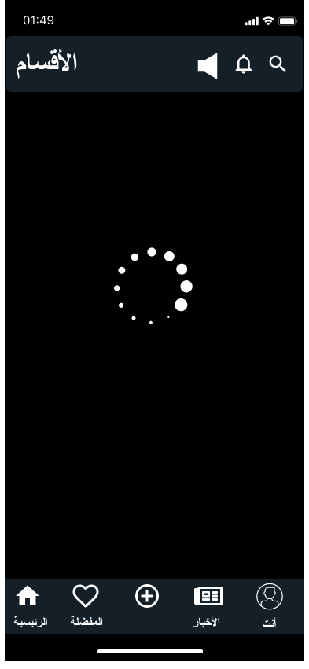

**3-Home screens**

**According to 8 gloden rules:”The design has accomplished strive for consistency”**

**4-Register,Login ,logout screens**

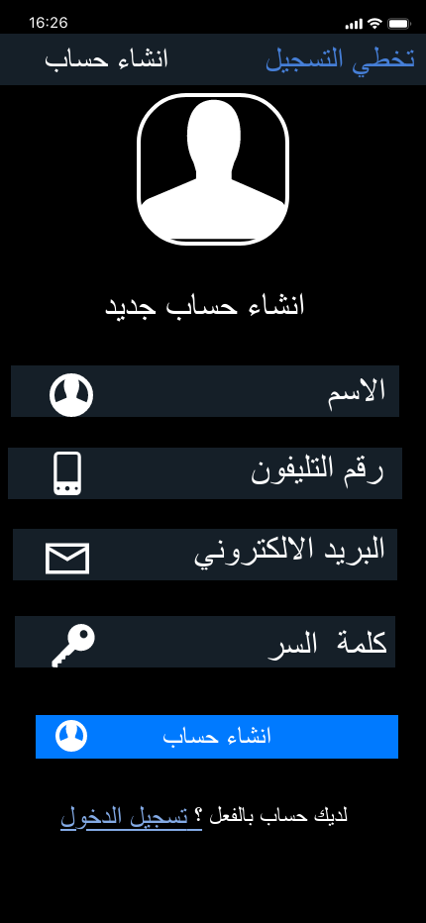

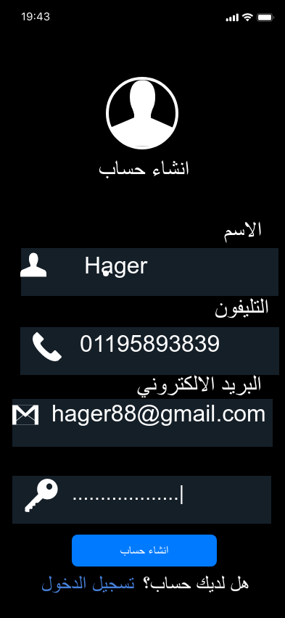

**According to 8 gloden rules:”The design has accomplished offer informative feedback”**

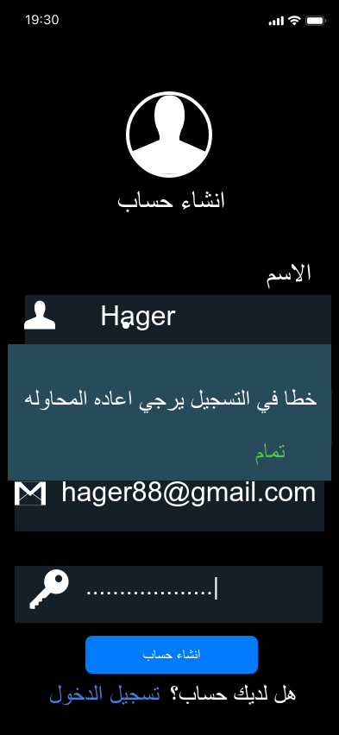

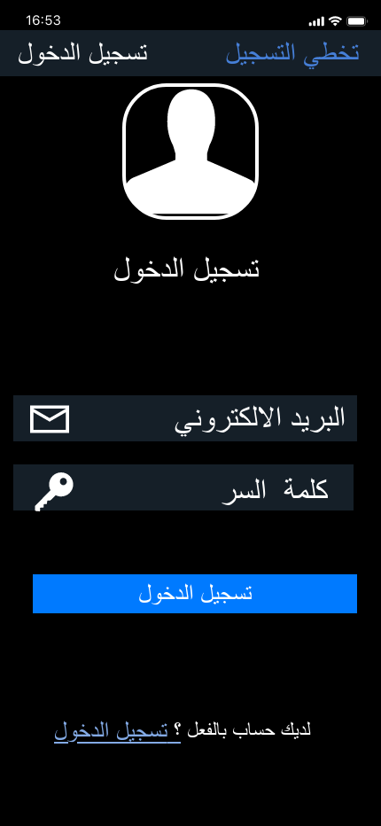

**According to 8 gloden rules:”The design has accomplished design dialogs to yield closure”**

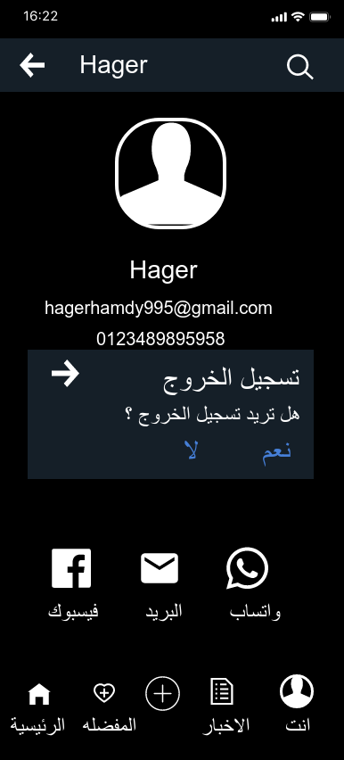

**5-Profile screens**

**According to Heuristic Rule:” The accessability icon was designed for people who have Visual impairment"**

**According to 8 gloden rules:”The design has accomplished seek universal usability”**

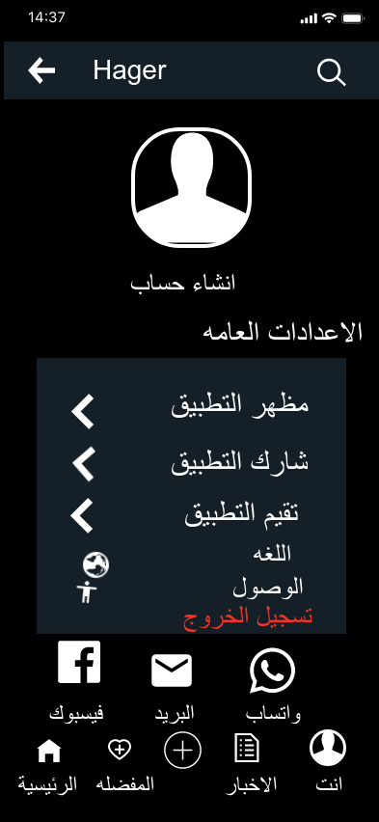

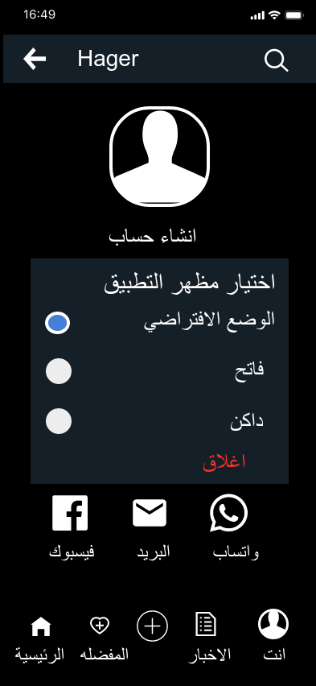

**6-Notification**



**According to Heuristic Rule:” The Speaker icon was designed for people who have Visual impairment"**

**According to 8 gloden rules:”The design has accomplished offer informative feedback”**



**7-Add news and posts**

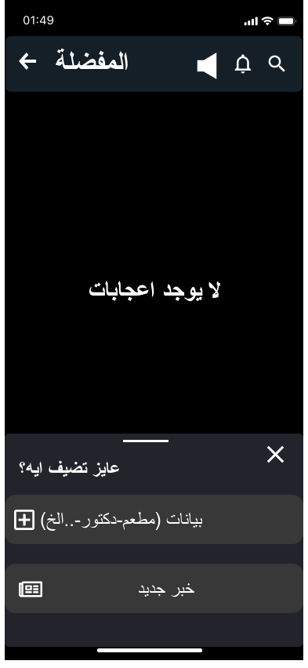

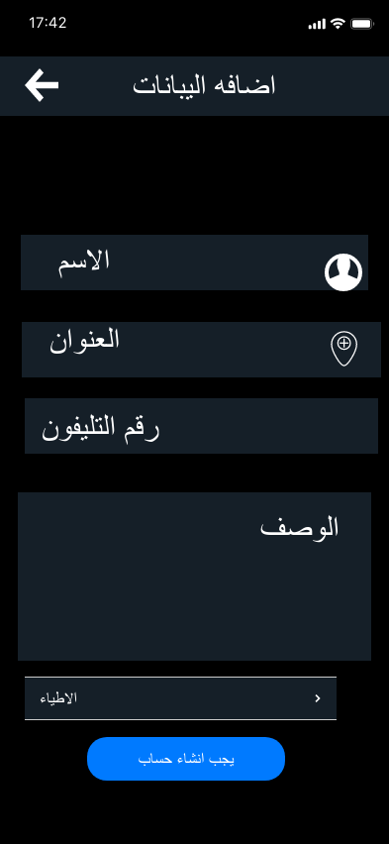

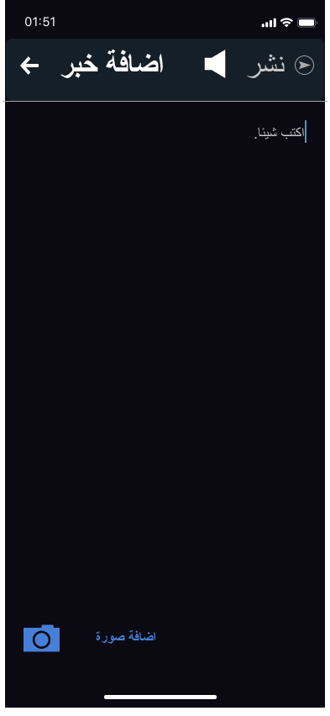

**According to Heuristic Rule:” The Speaker icon was designed for people who have Visual impairment"**

**8-News screens**

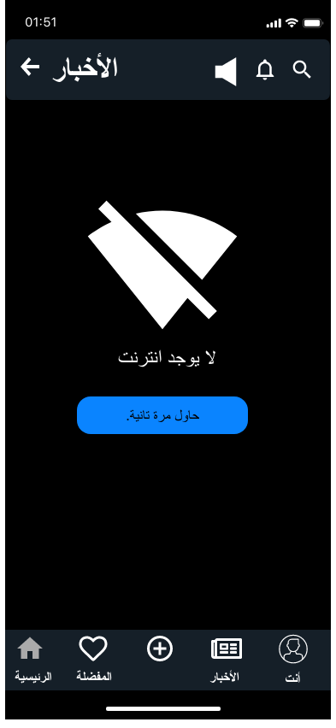

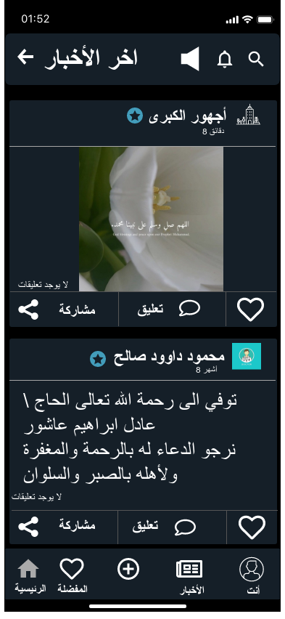

**9-Favourite Screen**

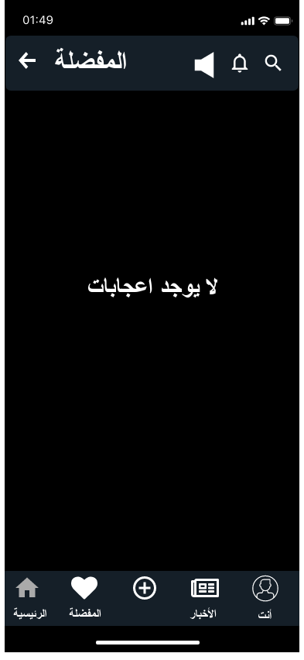

**10-category screens**

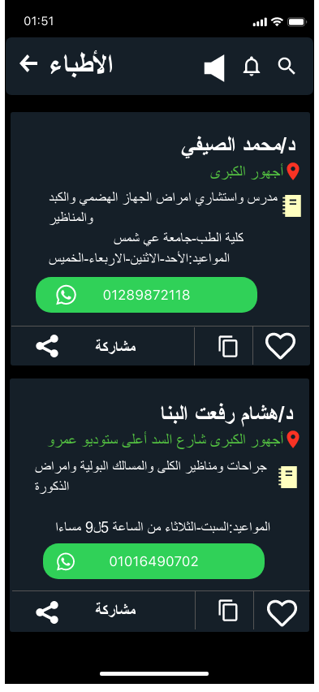

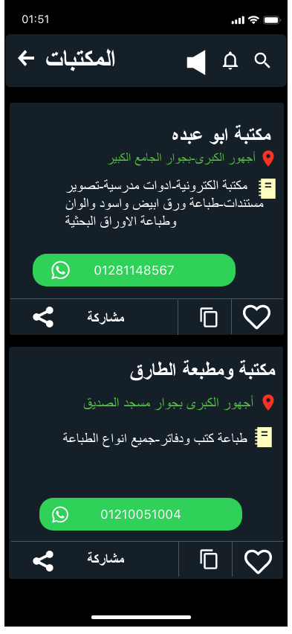

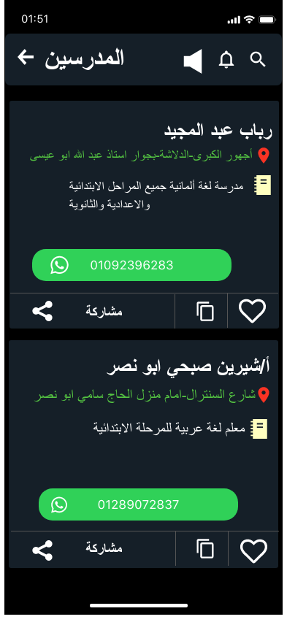

**According to Heuristic Rule:” The Speaker icon was designed for people who have Visual impairment"**

**11-search category screen**

